Atchison 70 Active

Performance Summary

Cumulative Returns

Downside Analysis

Rolling 3-Year Volatility

Risk Metrics

Asset Allocation

TAA Weight Changes

12 Month Attribution

12 Month Contribution

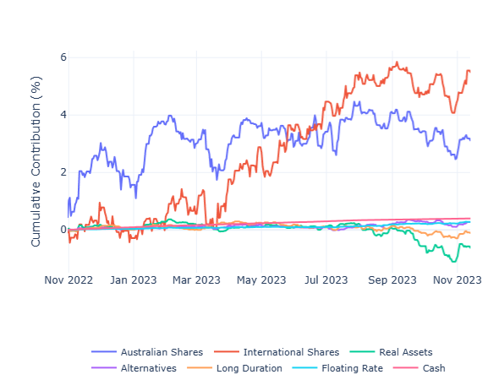

Underlying Aust Equities Sleeve

Look Through Exposures

Underlying Manager Cumulative Returns

Aggregate Style Analysis

Underlying Aus Equity – Size vs Earnings Growth

Underlying Aus Equity – ROE vs Profit Margin

Underlying Aus Equity – ROE vs PE / Ratio

Underlying Aus Equity – ROE vs Profit Margin

